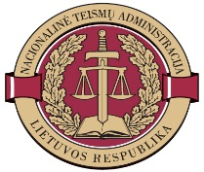

SECOND BALTIC SEMINAR
PROGRAMME

Monday 19 – Tuesday 20 October 2015
National Courts Administration (NCA), Vilnius, Lithuania

NAME AND ADDRESS OF THE HOSTING INSTITUTION / VENUE OF THE SEMINAR:
National Courts Administration (NCA), L. Sapiegos g. 15, Vilnius, Lithuania
official website http://www.teismai.lt/en/
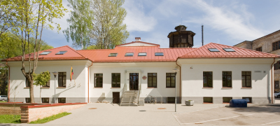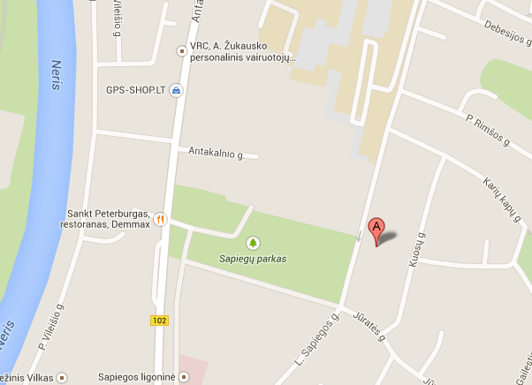

Monday, 19 October 2015 (moderator: L. Griškevič)
10:00 – 10:10 | Opening and Welcome Words  Mrs. Reda Molienė, Director of the National Courts Administration (Lithuania)
10:10 – 10:30 | Origins, Aims and Future perspectives of Baltic Seminars  Mr. Edvins Balsevics – Director of the Court Administration of Latvia  Mr. Rasmus Karja – Director of Legislative Drafting and Development Division of Judicial Administration Policy Department, Ministry of Justice  Mrs. Reda Molienė, Director of the National Courts Administration (Lithuania)
10:30 – 11:00 | Short Introduction to Lithuanian Judicial System (NCA and Self-governance of courts)  Ms. Lina Griškevič – Deputy Head of Legal Division, National Courts Administration (Lithuania)
11:00 – 11:30 | Short excursion to Exposition of Courts and Coffee break  (More info about the exposition can be found here)
11:30 – 12:00 | Priorities and Modernization trends in Lithuanian Judicial System:  - Communication with media and society;  - Witnesses and crime victims, psychological comfort and security in court buildings.  Mrs. Živilė Navickaitė-Babkin – Head of Communication Division, National Courts Administration (Lithuania)  Mrs. Žydrė Lyčienė – Chief Specialist of Communication Division, National Courts Administration (Lithuania)
12:00 – 12:30 | Lithuanian presentation: Introduction of the Quality Standards in Courts  Mrs. Reda Molienė, Director of the National Courts Administration (Lithuania)  Q&A / discussions
12:30 – 14:15 | Lunch
14:15 – 15:15 | Estonian presentation: The Changes in Preparatory Service to Become a Judge and Concept of Appointing of Substitute Judges  Mr. Rasmus Karja – Director of Legislative Drafting and Development Division of Judicial Administration Policy Department  Q&A / discussions
15:15 – 16:00 | Latvian presentation: Strengthening Competences of Judges and Court Staff: Trends and Developments  Mrs. Agnija Karlsone–Djomkina – Head of Project Management and International Cooperation Division, Court Administration of Latvia  Q&A / discussions
16:00 – 16:20 | Coffee break
16:20 – 17:00 | Panel discussion / future cooperation and knowledge sharing
19:00 | Welcome Dinner

Tuesday, 20 October 2015 (moderator: V. Petravičienė)

10:00 – 10:45 | Estonian presentation: the Idea of Digital Court File and the Version of Digital Court File in Testing  Ms. Margit Lauri – Adviser of Legislative Drafting and Development Division of Judicial  Q&A / discussions
10:45 – 11:30 | Estonian presentation: The Effect of Implementation of Public e-File  Ms Shirley Salm – Adviser of Legislative Drafting and Development Division of Judicial Administration Policy Department, Ministry of Justice  Q&A / discussions
11:30 – 11:50 | Coffee break
11:50 – 13:00 | Ernst & Young Baltic (EY). IT Trends and What's in for Justice  Mr. Artūras Piliponis – Partner, Advisory Services Ernst & Young Baltic UAB  Q&A / discussions
13:00 – 14:00 | Lunch
 | Possibility to visit the Palace of the Grand Dukes of Lithuania http://www.valdovurumai.lt/en

___________

Contact person at the National Courts Administration (Lithuania): for any organizational issues, please do not hesitate to contact Ms Judita Tamošiūnaitė, Chief Specialist of Training and International Cooperation Division: Phone +370 52514126, email: judita.tamosiunaite@teismai.lt

